**UNIT 1**

1. **INTRODUCTION**

**1.1 Overview:**

The electric power system is considered to be composed of three functional blocks - generation, transmission and distribution. For a reliable power system, the generation unit must produce adequate power to meet customer’s demand, transmission systems must transport bulk power over long distances without overloading or jeopardizing system stability and distribution systems must deliver electric power to each customer’s premises from bulk power systems. Distribution system locates the end of power system and is connected to the customer directly, so the power quality mainly depends on distribution system. The reason behind this is that the electrical distribution network failures account for about 90% of the average customer interruptions. In the earlier days, the major focus for power system reliability was on generation and transmission only as these more capital cost is involved in these. In addition that insufficiency can cause widespread catastrophic consequences for both society and its environment. But now a days distribution systems have begun to receive more attention for reliability assessment.

Each energy storage technology usually includes a power conversion unit to convert the energy from one form to another. Two factors characterize the application of an energy storage technology. One is the amount of energy that can be stored in the device. This is a characteristic of the storage device itself. Another is the rate at which energy can be transferred into or out of the storage device. This depends mainly on the peak power rating of the power conversion unit, but is also impacted by the response rate of the storage device itself.The concept of using the DVR as a power quality product has gained significant popularity since its first use.Various types of rechargeable energy storage technologies based on superconducting magnets (SMES), flywheels (FESS), batteries (BESS), and ultra-capacitors (UCAPs) are compared in for integration into advanced power applications such as DVR.

**1.2 Definition of power quality:**

Power qualityis a term that means different things to different people. Institute of Electrical and Electronic Engineers (IEEE) Standard IEEE1100 defines power qualities

“The concept of powering and grounding, sensitive electronic equipment in a manner suitable for the equipment.”

As appropriate as this description might seem,the limitation of power quality to “sensitive electronic equipment” might be subject to disagreement. Electrical equipment susceptible to power quality or more appropriatelyto lack of power quality would fall within a seemingly boundless domain. All electrical devices are prone to failure or malfunction when exposed to one or more power quality problems. The electrical device might be an electric motor, a transformer, a generator, a computer, a printer, communication equipment, or a household appliance. All of these devices and others react adversely to power quality issues, depending on the severity of problems.

A simpler and perhaps more concise definition might state: “Power quality is a set of electrical boundaries that allows a piece of equipment to function in its intended manner without significant loss of performance or life expectancy.”

**1.3 POWER QUALITY ISSUES:**

Power quality is a simple term, yet it describes a multitude of issues that are foundin any electrical power system and is a subjective term. The concept of good andbad power depends on the end user. If a piece of equipment functions satisfactorily,the user feels that the power is good. If the equipment does not function as intended or fails prematurely, there is a feeling that the power is bad. In between these limits, several grades or layers of power quality may exist, depending on the perspective of the power user. Understanding power quality issues is a good starting point for solving any power quality problem. Figure 1.1 provides an overview of the power quality issues that will be discussed in this book.

Power frequency disturbances are low-frequency phenomena that result in voltagesags or swells. These may be source or load generated due to faults or switchingoperations in a power system. The end results are the same as far as the susceptibilityof electrical equipment is concerned. Power system transients are fast, short-duration events that produce distortions such as notching, ringing,  
and impulse. The mechanisms by which transient energy is propagated in power lines, transferred to other electrical circuits, and eventually dissipated are different from the factors that affect power frequency disturbances.

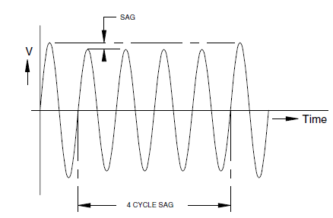

Fig.1.1 voltage sag

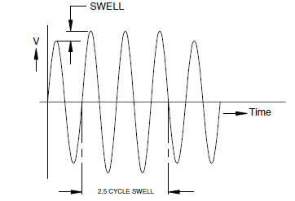

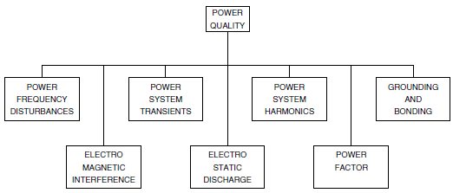Fig.1.2 Voltage swell

Fig.1.3 Power quality concern

Power system harmonics are low-frequency phenomena characterized by waveform distortion, which introduces harmonic frequency components. Voltage and current harmonics have undesirable effects on power system operation and power system components. In some instances, interaction between the harmonics and the power system parameters ( R–L–C ) can cause harmonics to multiply with severe consequences.

The subject of grounding and bonding is one of the more critical issues in power quality studies. Grounding is done for three reasons. The fundamental objective of grounding is safety, and nothing that is done in an electrical system should compromise the safety of people who work in the environment; in the U.S., safety grounding is mandated by the National Electrical Code (NEC ). The second objective of grounding and bonding is to provide a low-impedance path for the flow of fault current in case of a ground fault so that the protective device could isolate the faulted circuit from the power source. The third use of grounding is to create a ground reference plane for sensitive electrical equipment. This is known as the signal reference ground (SRG). The configuration of the SRG may vary from user to user and from facility to facility. The SRG cannot be an isolated entity. It must be bonded to the safety ground of the facility to create a total ground system.

Electromagnetic interference (EMI) refers to the interaction between electric and magnetic fields and sensitive electronic circuits and devices. EMI is predominantly a high-frequency phenomenon. The mechanism of coupling EMI to sensitive devices is different from that for power frequency disturbances and electrical transients. The mitigation of the effects of EMI requires special techniques, as will be seen later.

Radio frequency interference (RFI) is the interaction between conducted or radiated radio frequency fields and sensitive data and communication equipment. It is convenient to include RFI in the category of EMI, but the two phenomena are distinct.

Electrostatic discharge (ESD) is a very familiar and unpleasant occurrence. In our day-to-day lives, ESD is an uncomfortable nuisance we are subjected to when we open the door of a car or the refrigerated case in the supermarket. But, at high levels, ESD is harmful to electronic equipment, causing malfunction and damage.

Power factor is included for the sake of completing the power quality discussion. In some cases, low power factor is responsible for equipment damage due to component overload. For the most part, power factor is an economic issue in the operation of a power system. As utilities are increasingly faced with power demands that exceed generation capability, the penalty for low power factor is expected to increase. An understanding of the power factor and how to remedy low power factor conditions is not any less important than understanding other factors that determine the health of a power system.

**1.4 Power Quality in Distribution System:**

Electric distribution system power quality is a growing concern. Customers require higher quality service due to more sensitive electronic and computer-controlled loads. Capacitorswitching events and voltage sags associated with remote faults that never caused problems in the past now cause equipment tripping and even failures within customer facilities. Also, customer loads are generating increasing amounts of harmonic currents that can be magnified on the distribution system due to resonance conditions.

Electric utilities have addressed these concerns by establishing programs that can help customers evaluate problems and develop solutions. However, the solutions are often not simple because the problems involve interactions between the power system and the customer electrical system and equipment. Utility personnel dealing with distribution system design and power quality need to develop an understanding of how events on the distribution system can impact customer operations.

**1.5 Causes of voltage sags utility systems:**

* **Operation of Reclosers and Circuit breaker**

If, for any reason, a sub-station circuit breaker or a recloser is tripped, then the line that it is feeding will be temporarily disconnected. All other feeder lines from the same substation system will see this disconnection event as a voltage sag which will spread to consumers on these other lines. The depth of the voltage sag at the consumer’s site will vary depending on the supply line voltage and the distance from the fault. Typically, a higher supply voltage will have a larger sag affected zone.

* **Equipment Failure**

If electrical equipment fails due to overloading, cable faults etc., protective equipment will operate at the sub-station and voltage sags will be seen on other feeder lines across the utility system.

* **Bad Weather**

Thunderstorms and lightning strikes cause a significant number of voltage sags. If lightning strikes a power line and continues to ground, this creates a line-to-ground fault. The line-to- ground fault in turn creates a voltage sag and this reduced voltage can be seen over a wide area. Note the lightning strike to ground causes voltage sags on all other line. Circuit breakers and reclosers operate more frequently in poor weather conditions:

High winds can blow tree branches into power lines. As the tree branch strikes the line, a line-to-ground fault occurs which creates a voltage sag. If the line protection system does not operate immediately, a series of sags will occur if the branch repeatedly touches the power line. Broken branches landing on power lines cause phase-to-phase and phase-to-ground faults.

Snow and ice build-up on power line insulators can cause flash-over, either phase-to-ground or phase-to-phase. Similarly, snow or ice falling from one line can cause it to rebound and strike another line. These events cause voltage sags to spread through other feeders on the system.

* **Pollution**

Salt spray build-up on power line insulators over time in coastal areas, even many miles inland, can cause flashover, especially in stormy weather. Dust in arid inland areas can cause similar problems. As circuit protector devices operate, voltage sags appear on other feeders.

* **Animals & Birds**

Animals, particularly squirrels, raccoons and snakes occasionally find there way onto power lines or transformers and can cause a short circuit either phase-to-phase or phase-to-ground. Large birds, geese and swans, fly into power lines and cause similar faults. While the creature rarely survives, the protective circuit breaker operates and a voltage sag is created on other feeders.

* **Construction Activity**

Even when all power lines are underground, digging foundations for new building construction can result in damage to underground power lines and create voltage sags.

* **Industrial Plants:**

Voltage sags can be caused within an industrial facility or a group of facilities by the starting of large electric motors either individually or in groups. The large current inrush on starting can cause voltage sags in the local or adjacent areas even if the utility line voltage remains at a constant nominal value.

**1.6 Multi-phase sags and single-phase sags:**

* **Single-Phase Sags**

The most common voltage sags, over 90%, are single phase events which are typically due to a phase-to-ground fault occurring somewhere on the system. This phase-to-ground fault appears as a single phase voltage sag on other feeders from the same substation. Typical causes are lightning strikes, tree branches, animal contact etc. It is not uncommon to see single phase voltage sags to 30% of nominal voltage or even lower in industrial plants.

* **Phase-to-Phase Sags**

Two-phase, phase-to-phase sags may be caused by tree branches, adverse weather, animals or vehicle collision with utility poles. The two-phase voltage sag will typically appear on other feeders from the same substation.

* **Phase Sags**

Symmetrical three-phase sags account for less than 20% of all sag events and are caused either by switching or tripping of a three-phase circuit breaker, switch or recloser which will create a three-phase voltage sag on other lines fed from the same substation. Three-phase sags will also be caused by starting large motors, but this type of event typically causes voltage sags to approximately 80% of nominal voltage and are usually confined to an industrial plant or its immediate neighbor's.

## 1.7 Literature survey:

Power Quality in electric networks is one of today's most concerned areas of electric power system. The power quality has serious economic implications for consumers, utilities and electrical equipment manufacturers. The impact of power quality problems is increasingly felt by customers - industrial, commercial and even residential. Some of the main power quality problems are sag, swell, transients, harmonic, and flickers etc [2].

By custom power devices, we refer to power electronic static controllers used for power quality improvement on distribution systems rated from 1 to 38 kV . This interest in the practice of power quality devices (PQDs) arises from the need of growing power quality levels to meet the everyday growing sensitivity of customer needs and expectations . One of those devices is the Dynamic Voltage Restorer (DVR), which is the most efficient and effective modern custom power device used in power distribution networks. Its application includes lower cost, smaller size, and its fast dynamic response to thedisturbance.Several research papers and reports addressed the subject of improving power quality in distribution system by the use of custom power devices. The followings present a brief review of the work undertaken so far.

**1.N. H. Woodley, L. Morgan, and A. Sundaram**[1], was described solution to protect sensitive industrial loads against the most common voltage disturbances has been proposed. This solution is based in a power line conditioner, controlled to maintain the input voltage of a sensitive. The power line conditioner is controlled by a PR regulator, which is a simple controller that permits to avoid a sag detection stage and it is easy to carry out its grid-frequency adaptation.

2. **S. S. Choi, B. H. Li, and D.M. Vilathgamuwa**[2], was described Voltage sag is one of the most important power quality problems challenging the utility industry. Voltage sags can be compensated for by voltage and power injection into the distribution system. By injecting voltage with a phase advance with respect to the sustained source-side voltage, reactive power can be utilized to help voltage restoration. Hence, the consumption of real power, from the perspective of the energy supply device, can be reduced. This energy-saving voltage injection comes at the expense of an increased voltage injection magnitude, load power swing, phase shift, and discontinuity of voltage wave-shape.

**3. D. M. Vilathgamuwa, A. A. D. R. Perera, and S. S. Choi[3],** was describes the compensation capability of a dynamic voltage restorer (DVR) depend primarily on the maximum voltage injection ability and the amount of stored energy available within the restorer. A new phase advance compensation (PAC) strategy for the DVR is proposed in order to enhance the voltage restoration property of the device. The scheme requires only an optimum amount of energy injection from the DVR to correct a given voltage sag. Supply voltage amplitude and phase detection scheme as well as phase advance determination scheme are also included. The resulting DVR design is shown to be superior in terms of lower storage energy need compared to the conventional in-phase boosting method. The analytical results are validated by laboratory tests carried out on a prototype of the restorer. The efficacy of the proposed method is illustrated.

**4. Y. W. Li, D. M. Vilathgamuwa, F. Blaabjerg, and P. C. LohIn[4],** describes a robust control scheme with an outer Hinfin voltage control loop and an inner current control loop is designed and implemented on a medium-voltage (MV)-level dynamic voltage restorer (DVR) system. Through a simple selection of weighting functions, the synthesized Hinfin controller would exhibit significant gains in the vicinity of positive- and negative-sequence fundamental frequencies, and therefore, it would be able to regulate both positive- and negative-sequence components effectively, with explicit robustness in the face of system parameter variations. A detailed discussion of Hinfin controller weighting function selection, inner current loop tuning, and system disturbance rejection capability is presented. Finally, the designed control scheme is extensively tested on a laboratory 10-kV MV-level DVR system with varying voltage sag (balanced and unbalanced) and loading (linear/nonlinear load and induction motor load) conditions. It is shown that the proposed control scheme is effective in both balanced and unbalanced sag compensation and load disturbance rejection, as its robustness is explicitly specified.

**5.Ghosh and G. Ledwich**[5],describes a dynamic voltage restorer (DVR) is a power-electronic controller that can protect sensitive loads from disturbances in the supply system. In this paper, it is demonstrated that this device can tightly regulate the voltage at the load terminal against imbalance or harmonic in the source side. The behavior of the device is studied through steady-state analysis, and limits to achievable performance are found. This analysis is extended to the study of transient operation where the generation of the reference voltage of the DVR is discussed. Once the reference signals are generated, they are tracked using a switching band scheme. A suitable structure in which the DVR is realized by voltage-source inverters (VSIs) is also discussed. Particular emphasis to the rating of this device is provided. Extensive simulation results are included to illustrate the operating principles of a DVR.

**6.JohnGodsk Nielsen** [6],the compensation capability of a dynamic voltage restorer (DVR) depends primarily on the maximum voltage injection ability and the amount of stored energy available within the restorer. A new phase advance compensation (PAC) strategy for the DVR is proposed in order to enhance the voltage restoration property of the device. The scheme requires only an optimum amount of energy injection from the DVR to correct a given voltage sag.

**7.C.S. Chang, et al. [7]** presents performance of voltage sag mitigation devices such as the Dynamic Voltage Restorer (DVR) has been analyzed in highly simplified electrical environment consisting of simple line and load models. The negative influences of dynamic motor loads on the existing voltage disturbance, such as post-fault sags, further during-fault phase-angle deviations, during-fault and post-fault voltage fluctuations have often been unnoticed. First, the influence of induction motor operations on the during-fault and post-fault waveforms will be discussed. After which, the ability of the DVR to dynamically respond to the various types of voltage sag conditions at the terminals of a dynamic motor load and restore the sagging voltage to its pre-fault conditions is presented.

**Yash Pal, A. Swarup**, et al. [11] presents a comprehensive review of compensating custom power devices mainly DSTATCOM (distribution static compensator), DVR (dynamic voltage restorer) and UPQC (unified power quality compensator). It is aimed at providing a broad viewpoint on the status of compensating devices in electric power distribution system to researchers and application engineers dealing with power quality problems.

**Fawzi AL Jowder**, et al. [15] presents three different system topologies for dynamic voltage restorers (DVRs) are modeled and tested using Simulink , Sim Power System Toolbox for power system quality studies. The DVR controls are based on hysteresis voltage control. Simulation tests on radial distribution system, equipped with the DVR under three-phase and single-phase voltage sags with phase jump, are used to verify the operation of different DVR topologies. The modeled DVR topologies can be used to develop and test different, control strategies and methods for the DVR. These models can also aid instructors in teaching power quality courses.

**John Godsk Nielsen**, et al. [16] presents different control strategies for dynamic voltage restorer are analyzed with emphasis put on the compensation of voltage sags with phase jump.. Different control methods to compensate voltage sags with phase jump are here proposed and compared. Two promising control methods are tested with simulations carried out and finally tested on a 10 kVA rated Dynamic Voltage Restorer in the laboratory. Both methods can be used to reduce load voltage disturbances caused by voltage sags with phase jump. One method completely compensates the phase jump, which is the best solution for very sensitive loads.

**H.P. Tiwari**, et al. [20] presents dynamic voltage restorer against voltage sag. A dynamic voltage restorer (DVR) is a custom power device used to correct the voltage sag by injecting voltage as well power into the system. The mitigation capability of these devices is generally influence by the maximum load; power factor and maximum voltage dip to be compensated. Voltage Dip on a feeder is an main task for DVR system operation and appropriate desired voltage sag compensation. This paper is intended to assimilate the amount of DC energy storage depends on voltage dip. It is available in a convenient manner for DVR power circuit.

**D.N.Katole**, et al. [19] presents the Dynamic Voltage Restorer (DVR) with ESS based PI Controller method to compensate balanced voltage sag. Voltage sag is one of the major power quality problem which results in a failure or a mis-operation of end use equipments. Sensitive industrial loads and Utility distribution networks all suffer from various types of outages and service interruptions which can cost significant financial 1oss per event. The aim therefore, is to recommend measures that can improve voltage sag.

**Francisco Jurado**, et al. [21] presents fuzzy logic control of dynamic voltage restorer.. Some basic concepts of the DVR arc presented. Also describes the fundamentals of fuzzy logic. He presented a briefly discusses the application of fuzzy logic control in the field of PWM converter. The voltage error and its derivative are the Fuzzy Logic controller input crisp values. When a Fuzzy Logic controller is used, the tracking error and transient overshoots of PWM can be considerably reduced. The simulations carried out show that the Dynamic voltage restorer provides excellent voltage regulation capabilities.

**P.Ajay-D-Vimal Raj**, et al. [25] presents DVR with pi and fuzzy logic controller. The growing interest in power quality has led to a variety of devices designed for mitigating power disturbances, primarily voltage sags. Among several devices, a Dynamic Voltage Restorer (DVR) is a novel custom power device proposed to compensate for voltage disturbances in a distribution system. The compensation capability of a DVR depends primarily on the maximum voltage injection ability and the amount of stored energy available within therestorer.

**M.H.J Bollen**, et al. [26] presents the various characteristics of voltage sags experienced by customers within industrial distribution systems. Special stress is paid to the influence of the induction motor load on the characterization of voltage sags. During a fault, an induction motor operates as a generator for a short period of time and causes a raise in sag magnitude. Its reacceleration after the fault clearance results in an extended post-fault voltage sag. For an imbalanced fault, the induction motor current contains only positive- and negative-sequence components. Induction motors form a low impedance path for the negative-sequence voltage due to an imbalanced fault. This causes a small sustained nonzero voltage with large phase-angle jump in the faulted phase and a voltage drop in the non faulted phases with a small phase-angle jump. The symmetrical components of the induction motor during the imbalanced sags have been studied.

**UNIT 2**

**POWER QUALITY IN DISTRIBUTION GRID**

## 2.1 INTRODUCTION

The IEEE Standard Dictionary of Electrical and Electronics defines power quality as “the concept of powering and grounding sensitive electronic equipment in a manner that is suitable to the operation of that equipment.” Power quality may also be defined as “the measure, analysis, and improvement of bus voltage, usually a load bus voltage, to maintain that voltage to be a sinusoid at rated voltage and frequency”. Power quality is “the provision of voltages and system design so that the user of electric power can utilize electric energy from the distribution system successfully without interference or interruption.” A broad definition of power quality borders on system reliability, dielectric selection on equipment and conductors, long-term outages, voltage unbalance in three-phase systems, power electronics and their interface with the electric power supply and many other areas.

## 2.2 Power quality

Power quality in electric networks is one of today's most concerned areas of electric power system. The power quality has serious economic implications for consumers, utilities and electrical equipment manufacturers. Modernization and automation of industry involves increasing use of computers, microprocessors and power electronic systems such as adjustable speed drives. Integration of non-conventional generation technologies such as fuel cells, wind turbines and photo-voltaic with utility grids often requires power electronic interfaces. The power electronic systems also contribute to power quality problems (generating harmonics). Under the deregulated environment, in which electric utilities are expected to compete with each other, the customer satisfaction becomes very important. The impact of power quality problems is increasingly felt by customers - industrial, commercial and even residential.

**2.3 Problems associated with power quality**

## 2.3.1 Momentar phenomena

* + - 1. **2.3.1.1 Transients**

Transients are unwanted decay with time and hence not a steady state problem. A broad definition is that a transient is “that part of the change in a variable that disappears during transition from one steady state operating situation to the other". Another synonymous term which can be used is surge.

Transients are further classified into two categories:

1. Impulsive
2. Oscillatory

### 2.3.1.2 Long Duration Voltage Variations

When rms (root mean square) deviations at power frequency last longer than one minute, then we say they are long duration voltage variations. They can be either over voltages which is greater than 1.1p.u or under voltages which is less than 0.9p.u. Over voltage is due to switching off a load or energizing a capacitor bank. Also incorrect tap settings on transformers can result in over voltages. Under voltage are the results of actions which are the reverse of events that cause over voltages i.e. switching in a load or switching off a capacitor bank.

### 2.3.1.3 Sustained interruptions

If the supply voltage becomes zero for a period of time which is greater than one minute, then we can say that it is a sustained interruption. Normally, voltage interruption lasting for more than one minute is often unending and requires human intervention to restore the supply. The term “outage” is also used for long interruption. However it does not bring out the true impact of the power interruption. Even an interruption of half a cycle can be disastrous for a customer with a sensitive load.

### 2.3.1.4 Short Duration Voltage Variations

The short duration voltage variations are generally caused by fault conditions like single line to ground or double line to ground and starting of large loads such as induction motors. The voltage variations can be temporary voltage dips i.e. sag or temporary voltage rise i.e. swells or a absolute loss of voltage which is known as interruptions [3].

* **Voltage Sags**

Voltage sag is defined as the reduction of rms voltage to a value between 0.1 and 0.9p.u and lasting for duration between 0.5 cycle to 1 minute. Voltage sags are mostly caused by system faults and last for durations ranging from 3 cycles to 30 cycles depending on the fault clearing time. It is to be noted that under-voltages (lasting over a minute) can be handled by voltage regulation equipment. Starting of large induction motors can result in voltage dip as the motor draws a current up to 10 times the full load current during the starting. Also, the power factor of the starting current is generally poor.

### Voltage Swells

A voltage swell is defined as a raise in rms voltage which is between 1.1 and 1.8p.u for time duration between 0.5 cycles to 1 minute. A voltage swell is characterized by its magnitude (rms) and duration. As with sag, swell is associated with system faults. A SLG (single line to ground) fault can result in a voltage swell in the healthy phases. Swell can also result from energizing a large capacitor bank. On an ungrounded system, the line to ground voltages on the ungrounded phases is 1.73p.u during a SLG fault. However in a grounded system, there will be negligible voltage rise on the un-faulted phases close to a substation where the delta connected windings of the transformer provide low impedance paths for the zero sequence current during the SLG fault.

### Interruption

If the supply voltage or load current decreases to less than 0.1 p.u for a period of time not more than one minute is known as interruption. Interruption can be caused either by system faults, equipment failures or control malfunctions. The interruptions are measured by their duration alone. The duration due to a fault is determined by the operating time of the protective devices. Duration of an interruption due to equipment malfunction can be irregular. Some interruptions may also be caused by voltage sag conditions when there are faults on the source side.

## 2.3.2 Steady state phenomena

* + - 1. **2.3.2.1 Waveform Distortion**

This is defined as a steady-state deviation from an ideal sine wave of power frequency.

There are five types of waveform distortion:

1. DC offset
2. Harmonics
3. Inter harmonics
4. Notching
5. Noise

### 2.3.2.2 Voltage Imbalance

Voltage imbalance can be defined using symmetrical components. The ratio of the negative sequence or zero sequence components to the positive sequence component is a measure of unbalance. The main cause of voltage unbalance is single phase loads on a three phase circuit which resulting in load imbalance. Severe imbalance can be caused by single-phasing conditions in the system.

### 2.3.3 Voltage fluctuations and flicker

Voltage fluctuations are systematic variations of the voltage or a series of random changes in the voltage magnitude which lies in the range of 0.9 to 1.1p.u. High power loads that draw fluctuating current, such as large motor drives and arc furnaces, cause low frequency cyclic voltage variations that result in flickering of light sources like incandescent and fluorescent lamps which can cause significant physiological discomfort or irritation in human beings. The voltage flicker can also affect stable operation of electrical and electronic devices such as motors and CRT devices. The typical frequency spectrum of voltage flicker lies in the range from 1 Hz to 30Hz.

### 2.3.4 Power frequency variations

Power frequency variations are defined as the deviations of the system frequency from its particular value of 50 or 60 Hz. The variations in the frequency begin from the changes in the load and the response of the generators to meet the load. Thus the load characteristics which dependence on the frequency and the control characteristics of the generators change the shift in the frequency. In current interconnected power systems, frequency variations are insignificant most of the time unless governor and load frequency controls are disabled under a system of power shortages and a lack of grid discipline. Profitable incentives or disincentives that ensure balance between existing generation and load may help control over frequency variations under normal operating conditions.

## 2.4 Solution of power quality problems

For the improvement of power quality there are two approaches. According to first approach the solution to the power quality problems can be done from the utility side. The first approach is called load conditioning, which ensures that the equipment is less sensitive to power disturbances, allowing the operation even under significant voltage distortion. The other solution is to install line conditioning systems that suppress the power system disturbances. In this approach the compensating device is connect to low and medium voltage distribution system in shunt or in series. Shunt active power filters operate as a controllable current source and series active power filters operates as a controllable voltage source. Both schemes are implemented preferable with voltage source PWM inverters, with a dc source having a reactive element such as a capacitor. However, with the restructuring of power sector and with shifting trend towards distributed and dispersed generation, the line conditioning systems or utility side solutions will play a major role in improving the inherent supply quality; some of the effective and economic measures can be identified as following:

### 2.4.1 Thyristor based static switches:

The static switch is a versatile device for switching a novel element into the circuit when the voltage support is desired. It has a dynamic response time of about one cycle. To correct rapidly for voltage spikes, sags or interruptions, such static switch can used to switch one or more of devices such as capacitor, filter, alternate power line, energy storage systems etc. The static switch can be used in the alternate power line applications.

### 2.4.2 Energy storage systems:

Storage systems can be used to protect sensitive production equipments from shutdown which is caused by voltage sag or temporary interruptions. These are generally DC storage systems such as UPS, batteries, superconducting magnet energy storage (SMES), storage capacitors or even fly wheels driving DC generators are used. The output of these devices can be supplied to the system through an inverter on a momentary basis by a fast performing electronic switch like GTO or IGBT etc. Sufficient energy is fed to the system to compensate for the energy that would be lost by the fault conditions like voltage sag or interruption. However there are many different methods to mitigate voltage sags and swells, but the use of a custom Power device is considered to be the most efficient method. Flexible AC Transmission Systems (FACTS) for transmission systems, the term custom power pertains to the use of power electronics controllers in a distribution system, particularly, to deal with a variety of power quality problems. Just as FACTS improves the power transfer capabilities and stability limits, custom power makes sure customers get pre-specified quality and reliability of supply.

There are many types of Custom Power devices like Active Power Filters (APF), Battery Energy Storage Systems (BESS), Distribution static synchronous compensators (DSTATCOM), Dynamic Voltage Restorer (DVR), Surge Arresters (SA), Super conducting Magnetic Energy Systems (SMES), Static Electronic Tap Changers (SETC), Solid-State Transfer Switches (SSTS), Solid State Fault Current Limiter (SSFCL), and unified power quality conditioner (UPQC).

**2.5 Methods of action:**

**2.5.1 Existing method:**

Superconducting Magnetic Energy Storage is the existing method. Superconductivity was discovered in 1911, it was not until the 1970s that SMES was first proposed as an energy storage technology for power systems. SMES systems have attracted the attention of both electric utilities and the military due to their fast response and high efficiency. An SMES unit is a device that stores energy in the magnetic field generated by the dc current flowing through a superconducting coil.

An SMES unit consists of a large superconducting coil at the cryogenic temperature. This temperature is maintained by a cryostat or Dewar that contains helium or nitrogen liquid vessels. A power conversion/conditioning system (PCS) connects the SMES unit to an ac power system, and it is used to charge/discharge the coil.Two types of power conversion systems are commonly used. One option uses a current source converter (CSC) to both interface to the ac system and charge/discharge the coil. The second option uses a voltage source converter (VSC) to interface to the ac system and a dc–dc chopper to charge/discharge the coil.

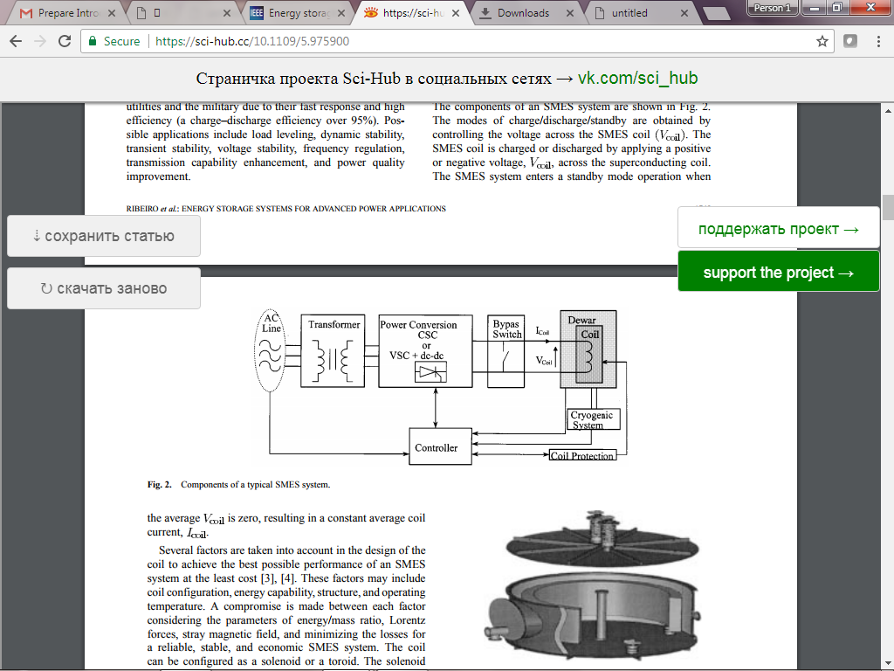

**Fig 2.1**Components of a typical SMES system

SMES systems have been considered for the following:

1) Load leveling

2) Frequency support (spinning reserve) during loss of generation

3) Enhancing transient and dynamic stability

4) Dynamic voltage support (VAR compensation)

5) Improving power quality; and

6) Increasing transmission line capacity

Thus enhancing overall reliability of power systems

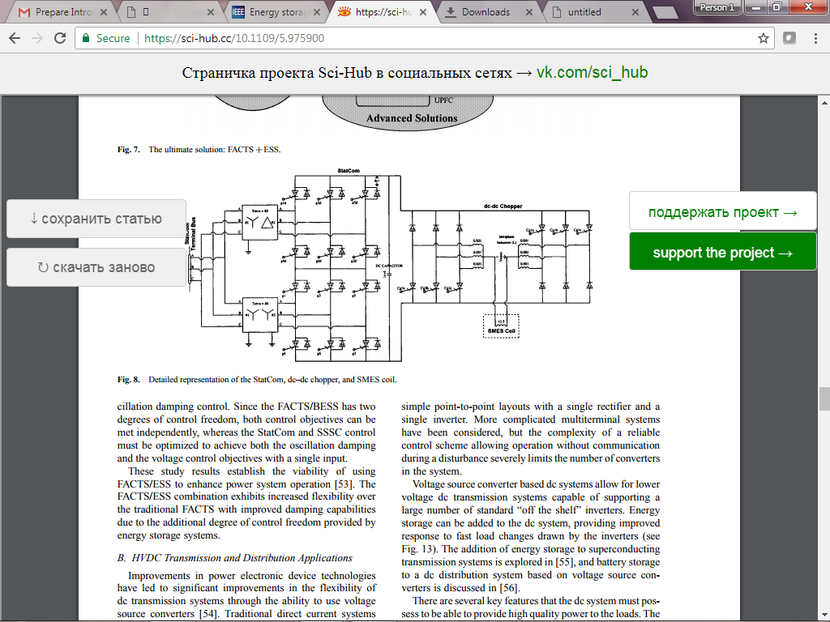

**Fig.2.2** Detailed representation of the Statcom, dc–dc chopper, and SMES coil

**2.5.2 Proposed method:**

The proposed method is UCAP-based energy storage integration to a DVR into the distribution grid. Ultra capacitors (UCAP) have low-energy density and high-power density ideal characteristics for compensation of voltage sags and voltage swells, which are both events that require high power for short spans of time. With these integration the following application areas are addressed.

1. Integration of the UCAP with DVR system gives active power capability to the system, which is necessary for independently compensating voltage sags and swells.
2. Experimental validation of the UCAP, dc–dc converter, and inverter their interface and control.
3. Development of inverter and dc–dc converter controls to provide sag and swell compensation to the distribution grid.
4. Hardware integration and performance validation of the integrated DVR-UCAP system.

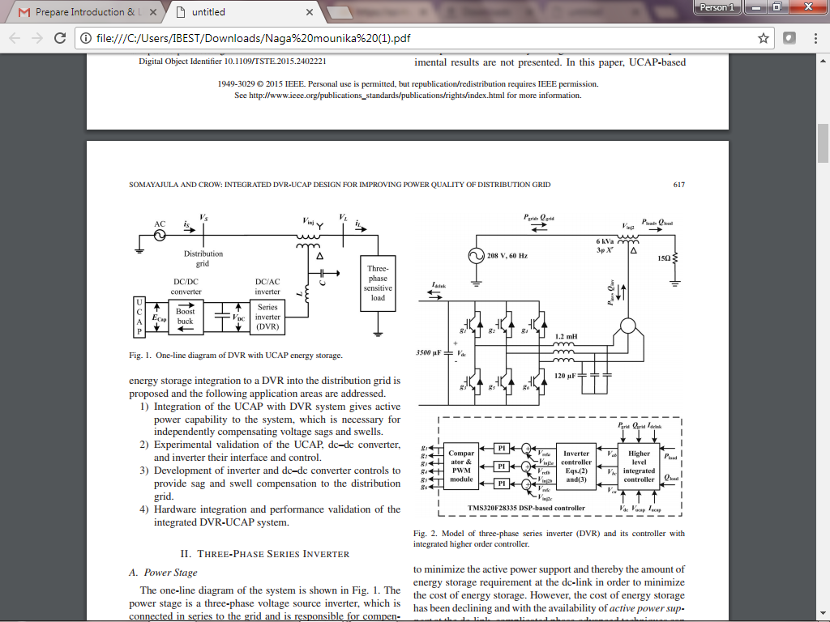

**Fig.2.3** One-line diagram of DVR with UCAP energy storage

**Advantages:**

* UCAPs have low-energy density and high-power density ideal characteristics for compensating voltage sags and voltage swells, which are both events that require high amount of power for short spans of time.
* UCAPs also have higher number of charge/discharge cycles when compared to batteries and for the same module size.
* UCAPs have higher terminal voltage when compared to batteries, which makes the integration easier.

## UNIT 3

**LOAD FLOW ANALYSIS IN 11 BUS DISTRIBUTION SYSTEM**

**3.1 Introduction:**

In power system when the load is varies with respect to demand, then causes to quality issues in power lines. Power quality can be degraded both due to utility side as well as the customer side abnormalities. Power quality issues are classifies in to voltage, current and frequency, which explains based on the operating limits and duty cycles. The load flow will be essential for the investigation of distribution networks, to research the issues identified with planning, outline and the operation and control. A few requirements like ideal distributed generation placement in distribution networks and distribution automation networks, obliges rehashed load flow result. Numerous systems such Gauss-Seidel, Newton-Raphson are generally appeared for convey the load flow of transmission networks. R/X ratio of distribution networks is high respect to transmission system, which cause the distribution networks to be badly modeled for ordinary load flow techniques. Some other natural aspects of electric distribution networks are

1. Radial or weakly meshed structure,
2. Unbalanced operation and unbalanced distributed loads,
3. Large number of nodes and branches,
4. Has wide range of resistance and reactance values and
5. Distribution network has multiphase operation.

The effectiveness of the optimization problem of distribution networks relies on upon the load flow algorithm on the grounds that load flow result need to run for ordinarily.

The load flow result of distribution networks must to have effort and time proficient qualities. A technique which can discover the load flow result of radial distribution networks specifically by utilizing topological normal for distribution system is utilized. In this strategy, the plan of Jacobian matrix or admittance matrix, which are needed in customary techniques, is stayed away from.

**3.2 Load flow studies in radial distribution networks:**

Inradial distribution system to solving networks having five types of methods are involved are given in the following:

1. Ladder technique method
2. Forward sweep and Backward sweep method
3. Current summation method
4. Power summation method
5. Impedance based method

In which forward sweep and backward sweep method is proposed in load flow technique for radial distribution system . The proposed method involves the solution of simple algebraic equation in receiving end voltages. The mathematical formulation of the proposed method is explained. Basically, the RDN(Radial Distribution Network) total power losses can be minimized by minimizing the branch power flow or transported electrical power from transmission networks (i.e. some percentage of load are locally meeting by local DG). To determine the total power loss of the network or each feeder branch and the maximum voltage deviation are determined by performing load flow.

**3.2.1 Forward sweep and backward sweep load flow method:**

The Forward and Backward Sweep Load Flow method is used in this network. The impedance of a feeder branch is computed by the specified resistance and reactance of the conductors used in the branch construction. The Forward and Backward sweep load flow method consist two steps (i) Backward sweep and (ii) Forward sweep.

**Backward sweep:** In this step, the load current of each node of a distribution network having

N number of nodes is determined as:



where, PL(m) and QL(m) represent the active and reactive power demand at node m and the over bar notation (x̅) indicates the phasor quantities, such as IL̅ , V¯ *. Then, the current in each branch of the network is computed as:

**

Where, ∑ the set consists of all nodes which are located beyond the node ‘n’

**Forward sweep:** This step is used after the backward sweep so as to determine the voltage at each node of a distribution network as follows:

**

where, nodes n and m represent the receiving and sending end nodes, respectively for the branch

mn and Z(mn) is the impedance of the branch.

In this work the estimation methodology utilized within the forward/backward load flow is based on

1. Equivalent current injections (ECI),
2. The node injection to branch current matrix (BIBC) and
3. The branch current to node voltage matrix (BCBV)

In this area, the advancement methodology will be depicted in sub element. Load flow for distribution networks under balanced operating condition with constant power load model can be under remained through the accompanying focus.

**3.2.2 Equivalent Current Injection:**

The technique is based on the equivalent current injection of a node in distribution networks, the equivalent current injection model is more practical. For any node of distribution networks, the complex load is expressed by

Si = Pi + jQi (3.4)

Where i = 1, … … … NB

Now, the equivalent current injection is expressed as



For the load flow solution equivalent current injection (ECI) at the kth iteration at ith node is computed as:

[IB] = [BIBC][I] (3.6)

**3.2.3 Formation of BIBC Matrix:**

The power injections at every node might be transformed into the equivalent current injections using the equations and applying Kirchhoff’s Current Law (KCL) at each and every node a set of comparisons could be composed. Now each and every branch currents of the network can be shaped as a function of the Equivalent Current Injections (ECI) .

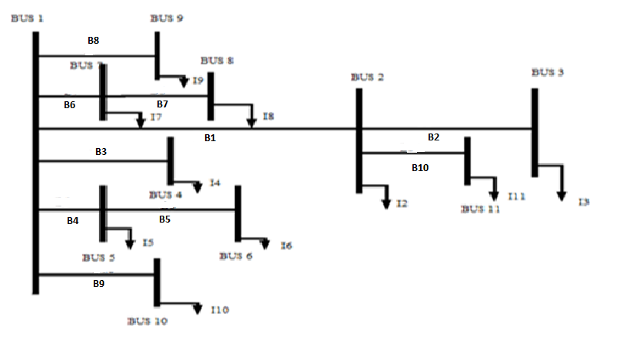

**Fig.3.1** Single line diagram of 11 bus system

As shown in Fig 3.1, the branch currents IB11, IB10, IB9, IB8 …..and IB1 can be expressed as:

IB1= I2+ I3 + I11

IB2 = I3

IB3 = I3

IB4 = I4

IB5 = I5 + I6 (3.7)

IB6 = I6

IB7 = I7 + I8

IB8 = I8

IB9 = I9

IB10 = I10

IB11 = I11

From eq.(1.7) the BIBC matrix can be written as:

= (3.8)

The general form of eq.(1.8) can be expressed as:

[IB] = [BIBC][I] (3.9)

The detailing of BIBC matrix for distribution networks is given in eq.(1.9) For general network, the BIBC matrix might be shaped through the accompanying steps and the example is done.

Step 1: Make an initial null BIBC matrix with a dimension of (m × (n − 1)). Where m and n are the number of branches and nodes available in the network.

Step 2: Initially set i=1 and read the IBi (i=1, 2, 3…m) branch data (i.e. sending end and receiving end node) from line-data matrix. If a line section IBi is located between Node ‘x’ and Node ‘y’. Check, that the IBi branch section of the network is belongs to the first node of the network or not. If it is, then make the (y-1, y-1)th bit of BIBC matrix by ‘+1’. Increment ‘i’ by one or go to the step3.

Step 3: If the in step2 the IBi branch section is not belongs to the first node of the network. Then copy the column segment of the (x-1)th node of BIBC matrix to the column segment of (y-1)th node and fill (y-1, y-1)th bit of the BIBC matrix by ‘+1’. Increment ‘i’ by one and go to the step2.

Step 4: Repeat step2 and step3 until all the branches of the network included in to the BIBC matrix.

**3.2.4 Formation of BCBV matrix:**

The Branch-Current to Node voltage (BCBV) matrix summarizes the relation between branch current and node voltages. The relations between the branch currents and node voltages can be obtained easily by applying Kirchhoff’s Voltage Law (KVL).

As shown in Fig.1.1 , the voltages of node 2, 3, and 4 are expressed as:

 (3.10)

 (3.11)

From equation it can be seen that the node voltage of the network can be expressed as a function of the branch currents, line parameters and main substation voltage. Similar approach can be employed for other nodes, and the Branch-Current to Node-Voltage (BCBV) matrix can be derived .

The general form of eq.(1.10) &(1.11) can be expressed as:

[ΔV] = [BCBV] [IB] (3.12)

-=

The formulation of BCBV matrix for distribution networks, the BCBV matrix can be formed through the subsequent steps:

Step 1: Make an initial null BVBC matrix with a dimension of (n-1)*m). Where m and n are the number of branches and nodes available in the network.

Step 2: initially set i=1 and read the IBi (i=1, 2, 3…m) branch data (i.e. sending end and receiving end node) from line-data matrix. If a line section IBi is located between Node ‘x’ and Node ‘y’. Check, that the IBi branch section of the network is belongs to the first node of the network or not. If it is, then make the (y-1, y-1)th bit of BVBC matrix by the corresponding branch impedance (Zxy). Increment ‘i’ by one or go to the step3.

Step 3: If the in step2 the IBi branch section is not belongs to the first node of the network. Then copy the row segment of the ‘(x-1)th’ node of BVBC matrix to the row segment of (y-1)th node and fill (y-1, y-1)th bit of the BVBC matrix by the corresponding branch impedance (Zxy). Increment ‘i’ by one and go to the step2.

Step 4: Repeat step2 and step3 until all the branches of the network included in the BVBC matrix.

It can be seen that the algorithms for the both BIBC and BCBV matrices are virtually identical. Basic formation difference of BIBC matrix and BCBV matrix is that, in BIBC matrix (x-1)thnode column is copied to the column of the (y-1)th  node and fill with +1 in the (x-1)th row and the (y-1)th node column, while in BCBV matrix row of the (x-1)th node is copied to the row of the (y-1)th node and fill the line impedance (Zxy) in the position of the (y-1)th node row and the ith column.

**3.3 Algorithm for forward sweep and backward sweep method:**

Step 1: Read the distribution networks line data and bus data.

Step 2: Calculate the each node current or node current injection matrix. The relationship can be expressed as –



Step 3: Calculate the BIBC matrix by using steps

Step 4: Evaluate the branch current by using BIBC matrix and current injection matrix (ECI).

The relationship can be expressed as -[IB] = [BIBC][I]

Step 5: Form the BCBV matrix by using steps. The relationship therefore can be expressed as

[∆V] = [BCBV][IB]

Step 6: Calculate the DLF matrix .

The relationship will be -[DLF] = [BCBV][BIBC]

[∆V] = [DLF][I]

Step 7: Set Iteration k = 0.

Step8: Iteration k = k + 1.

Step 9: Update voltages by using eqs. as –



[Vk+1] = [V0] + [∆Vk+1]

Step 10: If max ((|V(k+1)| − |V(k)|) > tolerance) go to step 6.

Step 11: Calculate branch currents, and losses from final node voltages.

Step 12: Display the node voltage magnitudes and angle, branch currents and losses.

Step 13: Stop

The above algorithm steps are shown in Flowchart given as Fig.3.2.

**3.4 Flow chart for forward sweep and backward sweep method**:



START

Read System Input Data;

Calculate the equivalent current injection matrix;

Calculate BIBC matrix by the backward sweep method;

Calculate BCBV matrix by forward sweep method;

Calculate DLF Matrix and Set iteration k = 0;

Iteration k = k+1

Update Voltages

YES

|V (k+1)|-|V (k)|

>tolerance?

NO

Calculate line flow & losses using final node voltages;

STOP

**Fig. 3.2** Flowchart for load flow solution for radial distribution networks

## 3.5 Test system:

The proposed system taking a validate Standard IEEE -11 bus system and give the bus data and line data to the system and it is shown in below fig.3.1. It has a 11 buses and interconnected to as bus data and line data. In which all the bus data and line data values are taken as p.u. values. Calculating the bus voltage and line current by using forward sweep and back ward sweep method. These output values are shown in table 3.2.

**Table 3.1** Bus data and line data of IEEE-11 bus system

|  |  |  |  |  |  |  |
| --- | --- | --- | --- | --- | --- | --- |
| Bus data | | | Line data | | | |
| Bus no | Real power  (p.u) | Reactive power(p.u) | From | To | Resistance  (ohm) | Reactance  (mho) |
| 1 | 0 | 0 | 1 | 2 | 0.04997 | 0.06644 |
| 2 | 1.22 | 0.916 | 2 | 3 | 0.02332 | 0.03310 |
| 3 | 0.032 | 0.024 | 1 | 4 | 0.04664 | 0.06201 |
| 4 | 0.778 | 0.584 | 1 | 5 | 0.02082 | 0.02768 |
| 5 | 0.673 | 0.595 | 5 | 6 | 0.02500 | 0.03322 |
| 6 | 1.22 | 0.916 | 1 | 7 | 0.02665 | 0.03543 |
| 7 | 0.0488 | 0.0366 | 7 | 8 | 0.02748 | 0.03654 |
| 8 | 0.956 | 0.717 | 1 | 9 | 0.03331 | 0.04430 |
| 9 | 0.698 | 0.523 | 1 | 10 | 0.02082 | 0.02768 |
| 10 | 1.265 | 0.949 | 2 | 11 | 0.02082 | 0.02768 |
| 11 | 0.265 | 0.0949 |

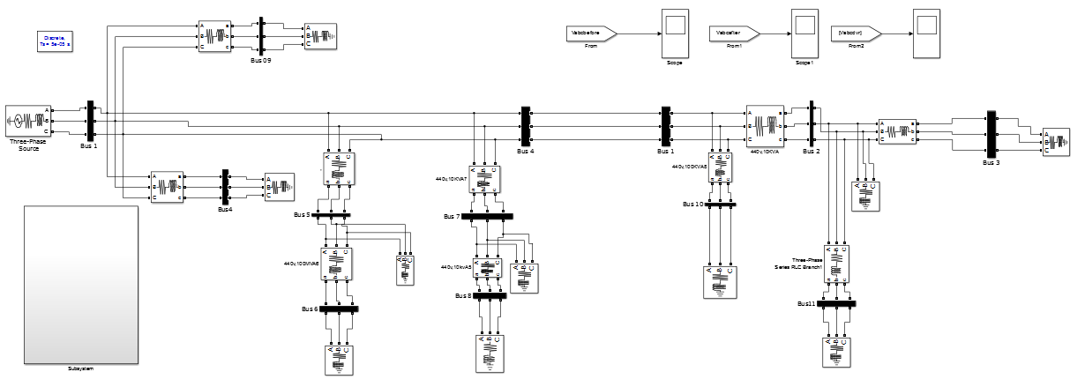

**Fig.3.3** Simulink diagram of IEEE-11 bus system

**Table 3.2.** Comparison of theoretical and practical values of output values

|  |  |  |  |  |
| --- | --- | --- | --- | --- |
| Bus | Theoretical | | Practical | |
|  | Line current | Bus voltage | Line current | Bus voltage |
| 1 | 1.5156 - 1.0329i | 1.0000 + 0.000i | 1.7694 - 1.3705i | 1.0000 + 0.0000i |
| 2 | 0.0320 - 0.0240i | 0.8556 - 0.0491i | 0.0372 - 0.0316i | 0.8205 - 0.0491i |
| 3 | 0.0320 - 0.0240i | 0.8541 - 0.0496i | 0.0320 - 0.0240i | 0.8186 - 0.0496i |
| 4 | 0.7780 - 0.5840i | 0.9275 - 0.0210i | 0.8300 - 0.6532i | 0.9208 - 0.0210i |
| 5 | 1.8635 - 1.4661i | 0.9206 - 0.0211i | 2.1433 - 1.8437i | 0.9043 - 0.0209i |
| 6 | 1.2200 - 0.9160i | 0.8597 - 0.0387i | 1.4149 - 1.1691i | 0.8301 - 0.0387i |
| 7 | 1.0029 - 0.7511i | 0.9467 - 0.0155i | 1.1096 - 0.8929i | 0.9388 - 0.0155i |
| 8 | 0.9560 - 0.7170i | 0.8942 - 0.0307i | 1.0583 - 0.8531i | 0.8785 - 0.0307i |
| 9 | 0.6980 - 0.5230i | 0.9536 - 0.0135i | 0.7260 - 0.5603i | 0.9510 - 0.0135i |
| 10 | 1.2650 - 0.9490i | 0.9474 - 0.0153i | 1.3234 - 1.0267i | 0.9440 - 0.0153i |
| 11 | 0.2650 - 0.0949i | 0.8475 - 0.0544i | 0.3176 - 0.1386i | 0.8101 - 0.0550i |

**UNIT 4**

**DYNAMIC VOLTAGE RESTORER-ULTRA CAPACITOR TOPOLOGY**

**4.1 Introduction:**

Initially for the improvement of power quality or reliability of the system FACTS devices like static synchronous compensator (STATCOM), static synchronous series compensator (SSSC), interline power flow controller (IPFC), and unified power flow controller (UPFC) etc., are introduced. These FACTS devices are designed for the transmission system. But now a day as more attention is on the distribution system for the improvement of power quality, these devices are modified and known as custom power devices. The term “custom power” describes the value-added power that electric utilities will offer to their customers. The value addition involves the application of high power electronic controllers to distribution systems, at the supply end of industrial, commercial consumers.

The main custom power devices which are used in distribution system for power quality improvement are distribution static synchronous compensator (DSTATCOM), dynamic voltage Restorer (DVR), active filter (AF), unified power quality conditioner (UPQC) etc. N.G Hingorani was the first to propose FACTS controllers for improving PQ. He termed them as Custom Power Devices (CPD). These are based on VSC and are of 3 types given below.

1. Shunt connected Distribution STATCOM(DSTATCOM)
2. Series connected Dynamic Voltage Restorer(DVR)
3. Combined shunt and series, Unified Power Quality Conditioner (UPQC).

The DVR is similar to SSSC while UPQC is similar to UPFC. In spite of the similarities, the control techniques are quite different for improving PQ. A major difference involves the injection of harmonic currents and voltages to separate the source from the load. A DVR can work as a harmonic isolator to prevent the harmonics in the source voltage reaching the load in addition to balancing the voltages and providing voltage regulation. A UPQC can be considered as the combination of Distribution Static Synchronous Compensator (DSTATCOM)and Dynamic Voltage Restorer(DVR). A DSTATCOM is utilized to eliminate the harmonics from the source currents and also balance them in addition to providing reactive power compensation to improve power factor or regulate the load bus voltage.

Several power providers have installed custom power devices for mitigating power quality problems. In particular, three major power quality devices (PQDs)—an advanced static VAR compensator, a dynamic voltage restorer, and a high-speed transfer switch are used these days. Over the past ten years, advanced power electronic devices have been the center of various research studies, installation projects, and development technologies.

By custom power devices, we refer to power electronic static controllers used for power quality development on distribution systems rated 1 through 38 kV. This interest in the usage of power quality devices (PQDs) arises from the need of mounting power quality levels to meet the everyday growing sensitivity of consumer needs and expectations. Power quality levels, if not achieved, can cause costly downtimes and customer dissatisfaction. According to contingency planning research company’s annual study, downtime caused by power disturbances results in major financial losses. In order to face these new needs, advanced power electronic devices have developed over the last years. Their performance has been demonstrated at medium distribution levels, and most are available as commercial products.

Among the power quality problems like sag, swell, harmonic etc, voltage sag is the most severe disturbances in the distribution system. To overcome these problems the concept of custom power devices is introduced lately. One of those devices is the Dynamic Voltage Restorer (DVR), which is the most efficient and effective modern custom power device used in power distribution networks.

DVR is a recently proposed series connected solid state device that injects voltage into the system in order to regulate the load side voltage. It is generally installed in a distribution system between the supply and the critical load feeder at the point of common coupling (PCC). Other than voltage sags and swells compensation, DVR can also added other features like line voltage harmonics compensation, reduction of transients in voltage and fault current limitations.

**4.2 Need of custom power devices**

Power quality is one of major concerns in the present era. Distribution system locates the end of power system and is connected to the customer directly, so the reliability of power supply mainly depends on distribution system. It has become important, especially, with the introduction of sophisticated devices, whose performance is very sensitive to the quality of power supply. Power quality problem is an occurrence manifested as a nonstandard voltage, current or frequency

that results in a failure of end use equipments. The electrical distribution network failures account for about 90% of the average customer interruptions.

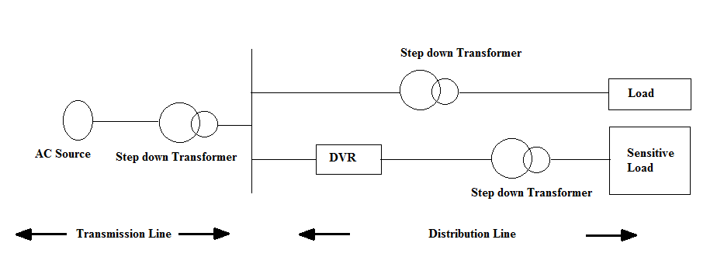**Fig.4.1** Location of DVR

As the customer’s demand for the reliability of power supply is increasing day by day, so the reliability of the distribution system has to be increased. One of the major problems dealt here is the power sag. Power distribution systems, ideally, should provide their customers with an uninterrupted flow of energy at smooth sinusoidal voltage at the contracted magnitude level and frequency. However, in practice, power systems, especially the distribution system, have numerous nonlinear loads, which significantly affect the quality of power supplies.

As a result of the nonlinear loads, the purity of the waveform of supplies is lost. This ends up producing many power quality problems. While power disturbance occur on all electrical systems, the sensitivity of today’s sophisticated electronic devices makes them more disposed to the quality of power supply. For some sensitive devices, a temporary disturbance can cause scrambled data, interrupted communications, a frozen mouse, system crashes and equipment failure etc. A power voltage spike can damage valuable components. To solve this problem, custom power devices are used. One of those devices is the Dynamic Voltage Restorer (DVR), which is the most efficient and effective modern custom power device used in power distribution networks. Its appeal includes lower cost, smaller size, and its fast dynamic response to the disturbance.

**4.3 Configurations**

The compensating type custom power devices can be classified on the basis of different topologies and the number of phases. For power quality improvement the voltage source inverter (VSI) bridge structure is generally used for the development of custom power devices, while the use of current source inverter (CSI) is less reported. The topology can be shunt (DSTATCOM), series (DVR), or a combination of both (UPQC).

### 4.3.1 CONVERTER BASED CLASSIFICATION

For the development of compensating type custom power devices the VSI is used usually, because of self-supporting dc voltage bus with a large dc capacitor, while the use of CSI is less reported. The current source inverter topology finds it application for the development of active filters, DSTATCOM and UPQC. The voltage source inverter topology is popular because it can be expandable to multilevel, multi-step and chain converters to enhance the performance with lower switching frequency and increased power handling capacity. In addition to this, this topology can exchange a considerable amount of real power with energy storage devices in place of the dc capacitor.

### 4.3.2 TOPOLOGY BASED CLASSIFICATION

Compensating type custom power devices can be classified based on the topology used as shunt (DSTATCOM), series (DVR) and combination of both series and shunt (UPQC). DSTATCOM is most widely used for power factor correction, to eliminate current based distortion and load balancing, when connected at the load terminals. DVR can perform voltage regulation when connected to a distribution bus.

**4.3.2.1 DSTATCOM**

A DSTATCOM is a custom power device which is utilized to eliminate the harmonics from the source currents and also balance them in addition to providing reactive power compensation to improve power factor or regulate the load bus voltage.

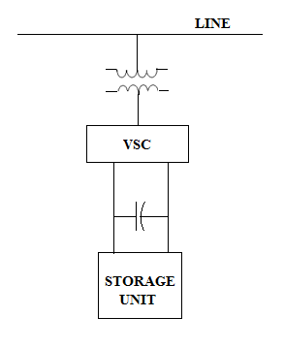

**Fig.4.2** Distribution Shunt connected STATCOM

**4.3.2.2 DVR (DYNAMIC VOLTAGERESTORER)**

A DVR is a custom power device which can work as a harmonic isolator to prevent the harmonics in the source voltage reaching the load in addition to balancing the voltages and providing voltage regulation. Dynamic Voltage Restorer is used as a custom power device in distribution system.

The series connected DVR can be shown in figure.

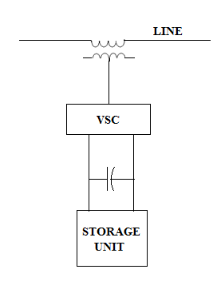

**Fig.4.3** Series connected dynamic voltage restorer

**4.3.2.3 UPQC (UNIFIED POWER QUALITY CONDITIONER)**

A UPQC is also a custom power device which can be considered as the combination of DSTATCOM and DVR.

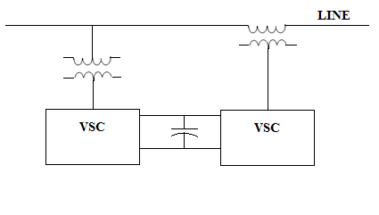

**Fig.4.4** Unified power quality Conditioner.

**4.3.3 Supply system based classification**

This classification of compensating devices is based on the supply and/or the load system having single-phase (two wire) and three-phase (three-wire or four-wire) systems. There are many nonlinear loads, such as domestic appliances, connected to single-phase supply systems. Some three-phase nonlinear loads are without neutral, such as ASD's, fed from three-wire supply systems. There are many nonlinear single-phase loads distributed on four-wire three-phase supply systems, such as computers, commercial lighting, etc. Hence, compensating devices may also be classified accordingly as two-wire, three wire, and four-wire types.

**4.4 Benefits with the applications of custom power devices**

The custom power devices such as DVR, DSTATCOM, UPQC, etc are used to increase the reliability of the distribution system by providing voltage support at critical buses in the system (with series connected controllers) and regulate power flow in critical lines (with shunt connected) like DSTATCOM. Both voltage and power flow are controlled by the combined series and shunt controller which is known as UPQC. As we know that the power electronic control is quite fast and this enables regulation both under steady state and dynamic conditions as compared to other controllers when the system is subjected to disturbances. The benefits due to custom power devices are listed below.

1. The power flow in critical lines can be improved as the operating margins can be reduced by fast controllability.
2. The power carrying capacity of lines can be increased to values up to the thermal limits by imposed by current carrying capacity of the conductors.
3. The transient stability limit is improved thereby improving dynamic security of the system and reducing the incidence of blackouts caused by cascading outages.
4. They contribute to best possible system operation by improving voltage profile and reducing power losses.
5. The steady state or small signal stability region can be increased by providing auxiliary stabilizing controllers to damp low frequency oscillations.
6. FACTS controllers such as TCSC can counter the problem of Sub synchronous Resonance (SSR) experienced with fixed series capacitors connected in lines evacuating power from thermal power stations (with turbo generators).
7. The problem of voltage fluctuations and in particular, dynamic over voltages can be overcome by these controllers.
8. The problem of starting voltage dip in case of industrial loads like induction motor can also be reduced by these devices.

These are the benefits with the applications of custom power devices.

**4.2 Principle of DVR operation**

A DVR is a solid state power electronics switching device consisting of either GTO or IGBT, a capacitor bank as an energy storage device and injection transformers. It is linked in series between a distribution system and a load. The basic idea of the DVR is to inject a controlled voltage generated by a forced commuted converter in a series to the bus voltage by means of an injecting transformer. A DC to AC inverter regulates this voltage by sinusoidal PWM technique. All through normal operating condition, the DVR injects only a small voltage to compensate for the voltage drop of the injection transformer and device losses. However, when voltage sag occurs in the distribution system, the DVR control system calculates and synthesizes the voltage required to preserve output voltage to the load by injecting a controlled voltage with a certain magnitude and phase angle into the distribution system to the critical load.

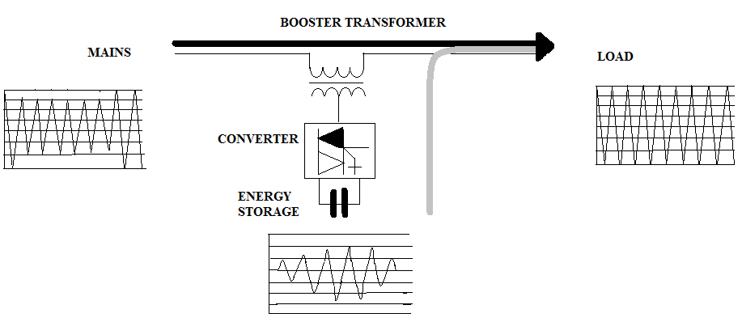Note that the DVR capable of generating or absorbing reactive power but the active power injection of the device must be provided by an external energy source or energy storage system. The response time of DVD is very short and is limited by the power electronics devices and the voltage sag detection time. The predictable response time is about 25 milliseconds, and which is much less than some of the traditional methods of voltage correction such as tap- changing transformers.

**Fig.4.5** Principle of DVR system

**4.3 Basic arrangement of DVR**

The DVR mainly consists of the following components:

1. An Injection transformer
2. DC charging unit
3. Storage Devices
4. A Voltage Source Converter(VSC)
5. Harmonic filter
6. 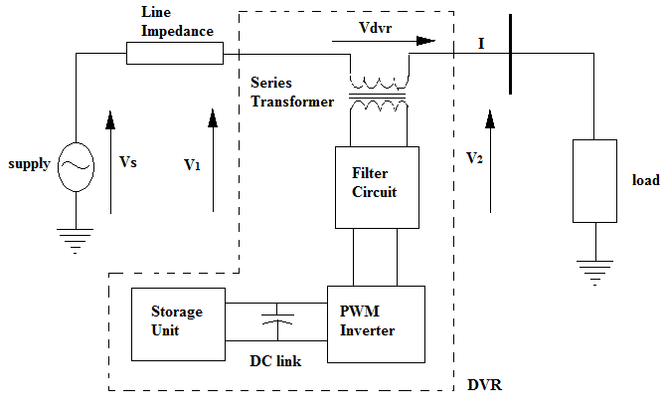A Control and Protection system

**Fig.4.6** Schematic diagram of DVR

**4.3.1 INJECTION TRANSFORMER**

Three single phase transformers are connected in series with the distribution feeder to couple the VSC (at the lower voltage level) to the higher distribution voltage level. It links the DVR system to the distribution network via the HV-windings and transforms and couples the injected compensating voltages generated by the voltage source converters to the incoming supply voltage. In addition, the Injection transformer also serves the purpose of isolating the load from the DVR system (VSC and control mechanism).

**4.3.2 DC CHARGING UNIT**

The dc charging circuit is used after sag compensation event the energy source is charged again through dc charging unit. It is also used to maintain dc link voltage at the nominal dc link voltage.

**4.3.3 VOLTAGE SOURCECONVERTER**

A VSC is a power electronic system consists of a storage device and switching devices, which can generate a sinusoidal voltage at any required frequency, magnitude, and phase angle. It could be a 3 phase - 3 wire VSC or 3 phase - 4 wire VSC. Either a conventional two level converter or a three level converter is used. For DVR application, the VSC is used to momentarily replace the supply voltage or to generate the part of the supply voltage which is absent. There are four main types of switching devices: Metal Oxide Semiconductor Field Effect Transistors (MOSFET), Gate Turn-Off thyristors (GTO), Insulated Gate Bipolar Transistors (IGBT), and Integrated Gate Commutated thyristors (IGCT).

Each type has its own benefits and drawbacks. The IGCT is a recent compact device with enhanced performance and consistency that allows building VSC with very large power ratings. The function of storage devices is to supply the required energy to the VSC via a dc link for the generation of injected voltages. The different kinds of energy storage devices are Superconductive magnetic energy storage (SMES), batteries and capacitance.

**4.3.4 HARMONIC FILTER**

As DVR consist of power electronic devices, the possibility of generation self harmonics is there so harmonic filter is also become a part of DVR. The main task of harmonic filter is to keep the harmonic voltage content generated by the VSC to the acceptable level.

**4.4 Mathematical modeling of Dynamic Voltage Restorer:**

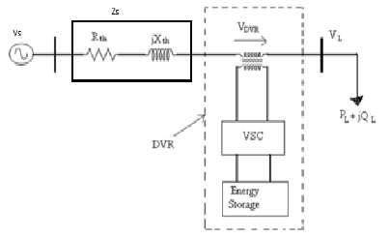

**Fig.4.7** DVR equivalent structure

Here the impedance Zline depends on the fault level of the load. When the system voltage (VS) drops or reduced from any specific value, the DVR injects a series voltage i.e. Vdvr through the injection transformer such that the desired load voltage VL can be maintained. Equivalent structure is represented in Fig 4.7. Here, load bus fault level decides system impedance Zs. At the time of voltage disturbance injection transformers injects voltage Vdvr to maintain load voltage magnitude VL.

If system voltage Vs drops, the injected voltage of DVR can be calculated as

(4.1)

Where, VL = desired load voltage magnitude

Zs = System impedance

IL = load current

Vs = system voltage during fault condition

Load current can be written as

(4.2)

Where

α, β and δ are the angle of Vdvr , Zs and Vs, and θ is the load power factor angle

(4.3)

DVR injected power can be written as

Sdvr (4.4)

**4.5 Operating modes of DVR**

The DVR is designed to inject a dynamically controlled voltage i.e. Vdvr, which is generated by a forced commutated converter. This voltage is injected in series to the bus voltage by means of an injection transformer. The momentary amplitudes of the three injected phase voltages are controlled such as to remove any harmful effects of a bus fault to the load voltage VL. This means that any differential voltages caused by transient disturbances in the ac feeder will be compensated by a equivalent voltage generated by the converter and injected on the medium voltage level through the injection transformer. The DVR has three modes of operation which are: protection mode, standby mode, injection/boost mode.

In protection mode, if the current on the load side exceeds a tolerable limit due to any fault or short circuit on the load, DVR will isolate from the system. In standby mode the voltage winding of the injection transformer is short circuited through converter. In the Injection/Boost mode the DVR is injecting a compensating voltage through the injection transformer due to the detection of a disturbance in the supply voltage.

**4.6 Voltage injection methods of DVR**

The voltage injection or compensation methods by means of a DVR mainly depend upon the limiting factors such as; DVR power ratings, different conditions of load, and different types of voltage sag.

There are different methods of DVR voltage injection which are

1. Pre-sag compensation method
2. In-phase compensation method

iii. In-phase advanced compensation method

**4.6.1 PRE SAGCOMPENSATION**

The supply voltage is always tracked and the load voltage is compensated to the pre-sag condition. This scheme results in undisturbed load voltage, but normally requires higher rating of the DVR. Before a sag occur, VS= VL= VO. Here VS is supply voltage, VL is load voltage and VOIS pre sag voltage. The voltage sag results in drop in the magnitude of the supply voltage VS1. The phase angle of the supply also may shift. The DVR injects a voltage VC1 such that the load voltage (VL = VS1 + VC1) remains at VO i.e. pre sag voltage (both in magnitude and phase). It is claimed that some loads are sensitive to phase jumps and it is essential to compensate for both the phase jumps and the voltage sags.

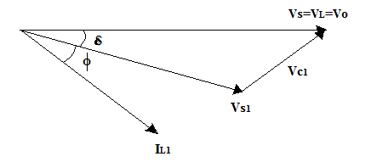

**Fig.4.8** Phasor diagram showing injected voltage by DVR

**4.6.2 IN PHASECOMPENSATION**

The voltage which is injected by the DVR is always in phase with the supply voltage in spite of the load current and the pre-sag voltage (Vo). This control strategy results in the minimum value of the injected voltage . However, the phase of the load voltage is disturbed. For loads which are not sensitive to the phase jumps, this control strategy results in optimum utilization of the voltage rating of the DVR. The power requirements for the DVR are not zero for this approach.

**4.6.3 IN PHASE ADVANCED COMPENSATION**

In this method the real power which is injected by the DVR is reduced by reducing the power angle between the voltage during sag condition and load current. The minimization of injected energy is achieved by making the active power component zero by having the injection voltage phasor perpendicular to the load current phasor. In this technique the values of load current and voltage are fixed in the system so only the phase of the voltage during sag is changed. This technique is only appropriate for a limited range of sag because this technique uses only reactive power and unfortunately, but al1 the sags cannot be mitigated without real power.

**4.6.4 MINIMUM ENERGY INJECTIO**N

In this injection method the injected voltage is in quadrature with load current. The power requirements of DVR are zero if the injected voltage by DVR is in quadrature with load current, neglecting losses. Minimum energy compensation strategy which considers the voltage limitation could control the active power exchange between DVR and the external system. The compensation capability of DVR could be maintained by the strategy not only when the injection voltage is under the voltage limitation but also when the injection voltage is above the voltage limitation. Both magnitude and phase control can be achieved by small or minimum energy injection.

**3.2 COMPENSATION SCHEME ANDCONTROL STRATEGY IMPLEMENTATION:**

The general principle of DVR is that whenever the system detects a voltage sag/swell, the DVR should react as fast as possible and inject an ac voltage into the grid. It can be implemented using the synchronous reference frame (SRF)technique based on the instantaneous values of the supply voltage. The control algorithm produces a three-phase reference voltage to the PWM inverter that tries to maintain the load voltage at its reference value. The voltage sag or swell is detected by measuring the error between the supply voltage and the reference value. The reference component is set to a rated voltage. The SRF method can be used to compensate all types of voltage disturbances, voltage sag/swell, voltage unbalance, and harmonic voltage. The difference between the reference voltage and the supply voltage is applied to the ZSI to produce the load rated voltage, with the help of pulse width modulation (PWM) through the

PI controller:





where𝜔 = rotation speed (rad/s) of the rotating frame

We have









**Fig.4.9** DVR control model

The definition of proportional feedback control is



Where

*e* = is the error, Kp= Proportional gain

The characterization of the essential feedback is



Where Ki =Integration gain factor

In the PI controller we have a combination of P in addition to PI control, that is







Where

Ti = Integration time, Tn = Reset time

In Proportional plus Integral Control action the actuating signal consists of proportional error signal with integral of the error signal. The block diagram is as shown in fig.4.10.

The input output relationship of PI control action when Kp = 1/t is



The transfer function of the system is

























*s*

*t*

*K*

*i*

*s*

*e*

*s*

*u*

*i*

*i*

Where

Gain Kp = 1 (already assumed) and Ti =integral time and Ti are constant and can be adjusted to any requiredvalues.

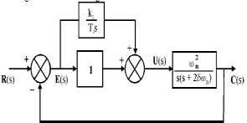

**Fig 4.10** Block diagram of proportional plus integral controller

## 3.3 Ultra capacitor:

Ultra-capacitor consists of the electrode, electrolyte, collector, exhaust valve, membrane for isolation, sealing materials and connection pole. The performance of Ultracapacitor depends on Electrode materials, composition of electrolyte, quality related to separation membrane and manufacturing technology. According to the energy storage mechanism, UCAP can be divided into three categories namely double-layer capacitor, metal-oxide electrode super-capacitor and organic polymer electrode Ultracapacitor. The frequently used carbon electrode double-layer capacitance is shown in Fig.4.11.

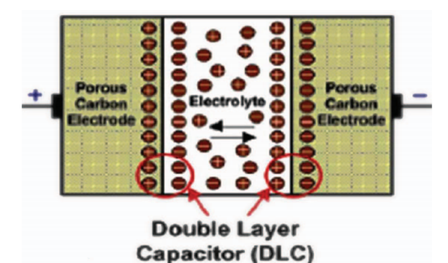

Fig.4.11 Ultra capacitor model

While charging, the positive plate attracts electrolyte anion and negative plate attracts cation, a double layer capacitor is formed on the surface of two layers, thus the name double layer capacitor. When discharging, it can release all stored energy instantly. UCAP is mainly suitable for short term high power application.

## Designin of ultra capacitor

Ultra-capacitor (UCAP) is used as energy storage device as it has high power density. It stores energy through charge separation and thus need for chemicals are reduced. The advantage of using UCAP is that they have long life time and it has large charge as well as discharge cycles. The choice of selecting the number of UCAPs depends on the factors such as a terminal voltage of UCAP, dc-link voltage and voltage of the distribution grid. In this , three UCAP each of 48 V are in series connection to obtain 144 V and capacitance of 165F. The design parameters are shown in TABLE 4.1. The value of capacitance and Equivalent series resistance (ESR) depends on the formula given by,



ESRsy = ESRcell * n (4.18)

The capacitance of the UCAP varies directly with the parallel plate area A and inversely with the distance a between the plates and is given by,





Where  is the vacuum permittivity constant and  is the relative constant of insulating dielectric between the plates.

**Design parameters:**

**Table 4.1** Design parameters

|  |  |
| --- | --- |
| PARAMETERS | RATINGS |
| Rated Voltage | 48 V |
| Leakage Current | 5.2 mA |
| Rated Capacitance | 165 F |
| ESR | 7 mΩ |
| Operating temperature | 25o C |

**Reference:**

|  |  |
| --- | --- |
| [1] | Deepak Somayajula, and Mariesa L. Crow, “ An Integrated Dynamic Voltage Restorer-Ultracapacitor Design for Improving Power Quality of the Distribution Grid”, *IEEE transactions on sustainable energy*, vol. 6, no. 2, Apr. 2015 |
| [2] | N. H. Woodley, L. Morgan, and A. Sundaram, “Experience with an inverter-based dynamic voltage restorer,” *IEEE Trans. Power Del.*, vol. 14, no. 3, pp. 1181–1186, Jul. 1999. |
| [3] | S. S. Choi, B. H. Li, and D.M. Vilathgamuwa, “Dynamic voltage restoration withminimum energy injection,” *IEEE Trans. Power Syst.*, vol. 15, no. 1, pp. 51–57, Feb.  2000. |
| [4] | D. M. Vilathgamuwa, A. A. D. R. Perera, and S. S. Choi, “Voltage sag compensation with energy optimized dynamic voltage restorer,” *IEEETrans. Power Del.*, vol. 18, no. 3, pp. 928–936, Jul. 2003. |
| [5] | A. Ghosh and G. Ledwich, “Compensation of distribution system voltage using DVR,” *IEEE Trans. Power Del.*, vol. 17, no. 4, pp. 1030–1036, Oct. 2002. |
| [6] | P. R. Sanchez, E. Acha, J. E. O. Calderon, V. Feliu, and A. G. Cerrada, “A versatile control scheme for a dynamic voltage restorer for power quality improvement,” *IEEE Trans. Power Del.*, vol. 24, no. 1, pp. 277–284, Jan. 2009. |
| [7] | C. S. Lam, M. C. Wong, and Y. D. Han, “Voltage swell and overvoltage compensation with unidirectional power flow controlled dynamic voltage restorer,” *IEEE Trans. Power Del.*, vol. 23, no. 4, pp. 2513–2521, Oct. 2008. |
| [8] | K. Sahay and B. Dwivedi, “Supercapacitor energy storage system for power quality improvement: An overview,” *J. Elect. Syst.*, vol. 10, no. 10, pp. 1–8, 2009. |
| [9] | R. S. Weissbach, G. G. Karady, and R. G. Farmer, “Dynamic voltage compensation ondistribution feeders using flywheel energy storage,” *IEEE Trans. Power Del.*, vol. 14,no.2, pp. 465–471, Apr. 1999. |
| [10] | P. F. Ribeiro, B. K. Johnson, M. L. Crow, A. Arsoy, and Y. Liu, “Energy storage systems  for advanced power applications,” *Proc. IEEE*, vol. 89, no. 12, pp. 1744–1756, Dec. 2001. |
| [11] | Yash Pal, A. Swarup, Senior Member, IEEE, and Bhim Singh, Senior Member, IEEE  “A Review of Compensating Type Custom Power Devices for Power Quality Improvement” IEEE Power India Conference, pp. 1-8, 2008. |
| [12] | H. K. Al-Hadidi, A. M. Gole, and D. A. Jacobson, “A novel configuration for a cascaded inverter-based dynamic voltage restorer with reduced energy storage requirements,” *IEEE Trans. Power Del.*, vol. 23, no. 2, pp. 881–888, Apr. 2008. |
| [13] | H. Akagi, E. H.Watanabe, and M. Aredes, *Instantaneous Reactive Power Theory and Applications to Power Conditioning*, 1st ed. Hoboken, NJ,USA: Wiley, Piscataway, NJ,  USA: IEEE Press, 2007. |
| [14] | Y. W. Li, D. M. Vilathgamuwa, F. Blaabjerg, and P. C. Loh “A robust control scheme for medium-voltage-level DVR implementation,” *IEEE Trans. Ind. Electron.*, vol. 54, no. 4,  pp. 2249–2261, Aug. 2007. |
|  | Fawzi AL Jowder “Modeling and Simulation of Different System Topologies for Dynamic Voltage Restorer” Electric Power and Energy Conversion Systems, EPECS '09. International Conference, IEEE, pp. 1-6, 2009. |
|  | John Godsk Nielsen and FredeBlaabjerg “Control Strategies forDynamicVoltageRestorer Compensating Voltage Sags with Phase Jump”, Applied Power Electronics Conference and Exposition, IEEE, vol. 2, pp. 1267-1273,2001. |
|  | H.P. Tiwari and Sunil Kumar Gupta “Dynamic Voltage Restorer against Voltage Sag” International Journal of Innovation, Management and Technology vol. 1, no. 3, pp. 232- 237, 2010. |
|  | D.N.Katole Research scholar: Department of Electrical Engg. G.H.Raisoni College of engineering Nagpur, Maharashtra, India. “Analysis and Mitigation of Balanced Voltage Sag with the Help of Energy Storage System” ICETET pp. 317-321, 2010. |
|  | Francisco Jurado, Member, IEEE, and Manuel Valverde University of Jaen, “Fuzzy logic control of a dynamic voltage restorer” IEEE-ISIE, vol. 2, pp. 1047-1052, 2004 |
|  | P.Ajay-D-Vimal Raj, M.Sudhakaran, S.Senthil Kumar, Sapta Rishi Roy, T.G.Palanivelu “multi level inverter based dynamic voltage restorer with pi and fuzzy logic controller” NSC, pp. 65-70, December 2008. |
|  | G. Yalcinkaya, M.J.H Bollen, P.A Crossley, “characterization of voltage sags in industrial distribution system”, IEEE transaction on industrial applications, vol.34, pp. 682-688 july- aug.1998. |
| [15] | S. Santoso, M. F. McGranaghan, R. C. Dugan, and H.W. Beaty, *Electrical Power Systems*  *Quality*, New York, NY, USA: McGraw-Hill, Jan.2012. |